Digital Nurture 4.0 – Week 6
React

(a) Mandatory hands-on
Filename : 1. ReactJS-HOL
Step 1:
Install node.js from official website and setup on the system.And Create a new folder named react1 for this project and open on vs code.

Step 2:
Run the command npx create-react-app myfirstreact on the vs code terminal.And redirect to the react folder named myfirstreact.Change the App.js code in the src/App.js directory.

App.js:
import React from 'react';
function App() {
return (
<div>
<h1>welcome to the first session of React</h1>
</div>
);
}

export default App;

Step 3:
Run the command npm start on your vs code terminal.
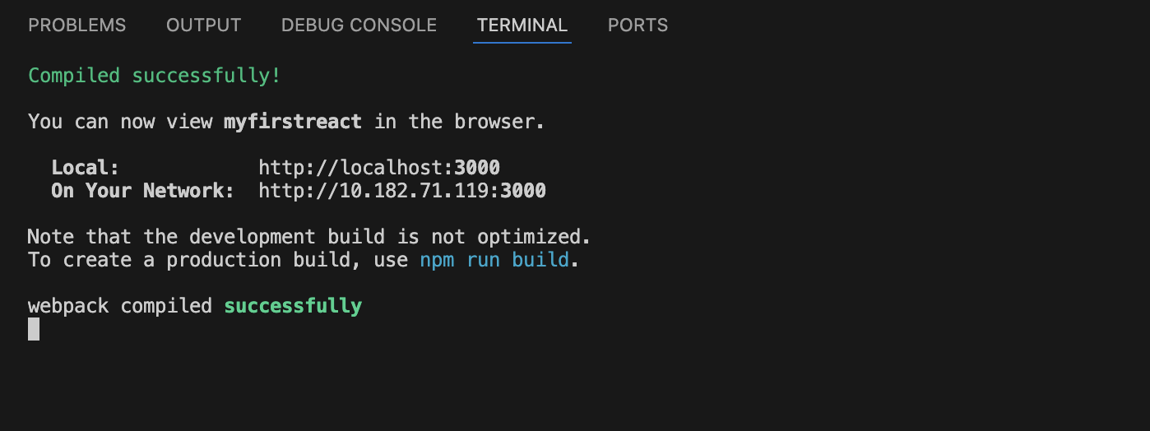

Then it opens in the browser.
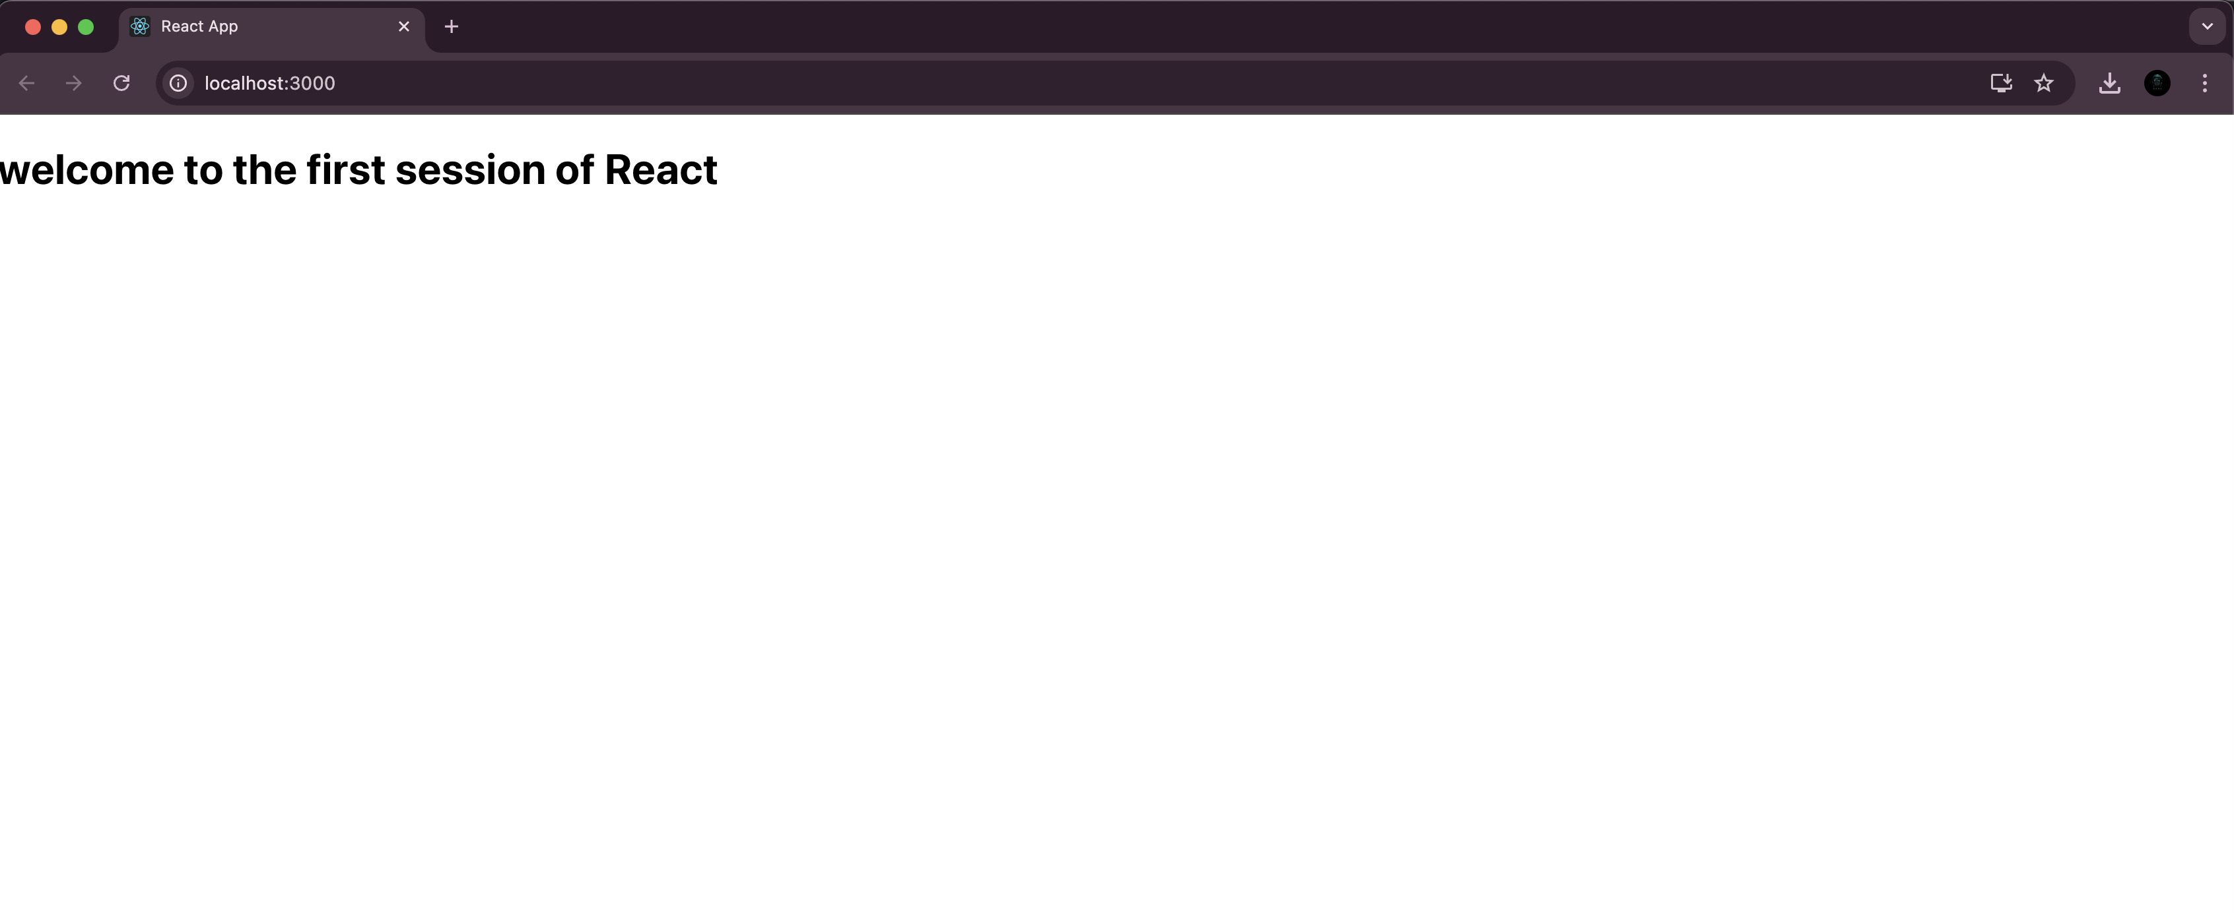
Filename : 2. ReactJS-HOL

Step 1:
Install node.js from official website and setup on the system.And Create a new folder named react2 for this project and open on vs code.

Step 2:
Run the command npx create-react-app studentapp on the vs code terminal.And redirect to the react folder named studentapp.Change the App.js code in the src/App.js directory.Create Home.js,About.js and Contact.js in the src/Components directory.

App.js:
import React from 'react';
import './App.css';
import Home from './Components/Home';
import About from './Components/About';
import Contact from './Components/Contact';

function App() {
return (
<div className="App">
<h1>Student Management Portal</h1>
<Home />
<About />
<Contact />
</div>
);
}
export default App;

Home.js:
import React from 'react';
function Home() {
return (
<div>
<h2>Welcome to the Home page of Student Management Portal</h2>
</div>
);
}

export default Home;

About.js:
import React from 'react';
function About() {
return (
<div>
<h2>Welcome to the About page of the Student Management Portal</h2>
</div>
);
}

export default About;

Contact.js:
import React from 'react';
function Contact() {
return (
<div>
<h2>Welcome to the Contact page of the Student Management Portal</h2>
</div>
);
}

export default Contact;

Step 3:
Run the command npm start on your vs code terminal.
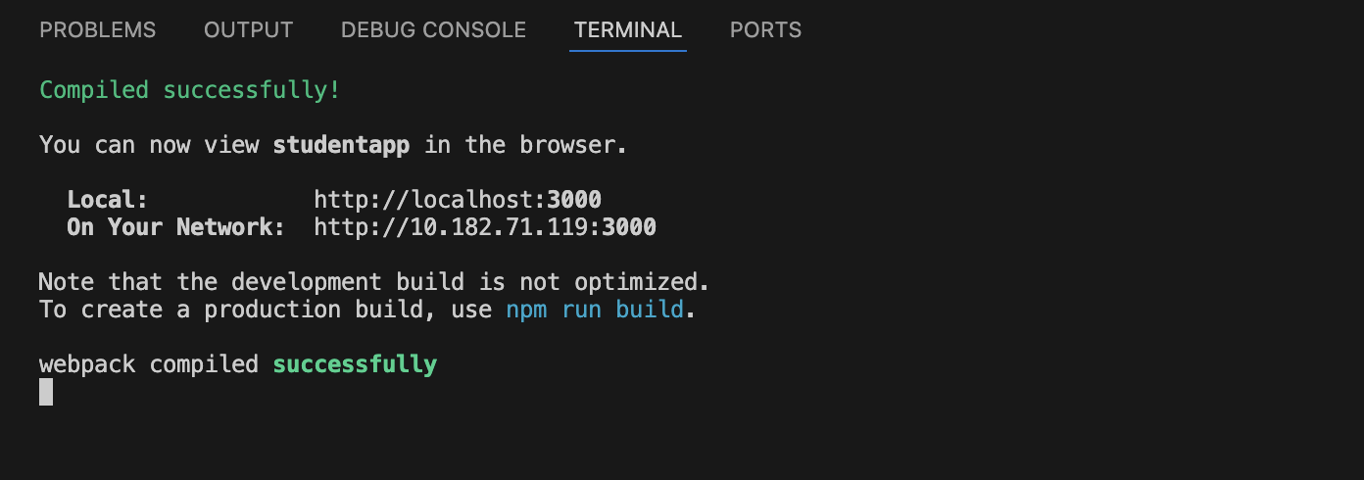

It will ope the browser.

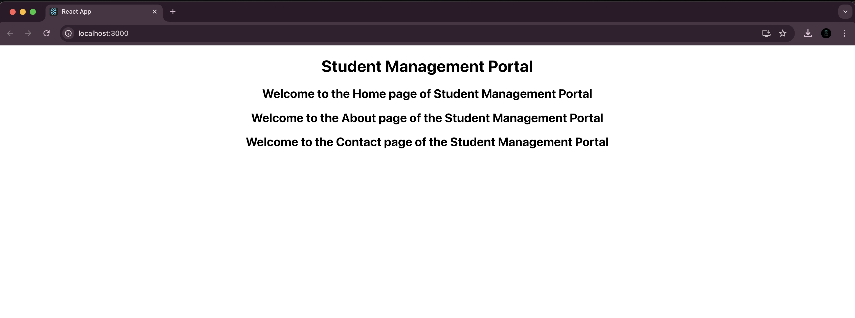

Filename : 3. ReactJS-HOL

Step 1:
Install node.js from official website and setup on the system.And Create a new folder named react3 for this project and open on vs code.

Step 2:
Run the command npx create-react-app scorecalculatorapp on the vs code terminal.And redirect to the react folder named scorecalculatorapp.Change the App.js code in the src/App.js directory.Create CalculateScore.js in the src/Components directory and mystyle.css in the src/Stylesheets directory.

App.js:
import React from 'react';
import './App.css';
import CalculateScore from './Components/CalculateScore';

function App() {
return (
<div className="App">
<CalculateScore
name="Alice Johnson"
school="Greenwood High"
total="420"
goal="5"
/>
</div>
);
}

export default App;

CalculateScore.js:
import React from 'react';
import '../Stylesheets/mystyle.css';

function CalculateScore(props) {
const average = (parseInt(props.total) / parseInt(props.goal)).toFixed(2);

return (
<div className="score-card">
<h2>Student Score Card</h2>
<p><strong>Name:</strong> {props.name}</p>
<p><strong>School:</strong> {props.school}</p>
<p><strong>Total Score:</strong> {props.total}</p>
<p><strong>Goal:</strong> {props.goal}</p>
<p><strong>Average Score:</strong> {average}</p>
</div>
);
}

export default CalculateScore;

mystyle.css:
.score-card {
background-color: #f0f8ff;
border: 2px solid #ccc;
border-radius: 10px;
padding: 20px;
margin: 20px auto;
width: 400px;
text-align: left;
box-shadow: 0 0 10px rgba(0, 0, 0, 0.1);
}

.score-card h2 {
color: #333;
text-align: center;
}
.score-card p {
font-size: 16px;
margin: 5px 0;
}
Step 3:
Run the command npm start on your vs code terminal.
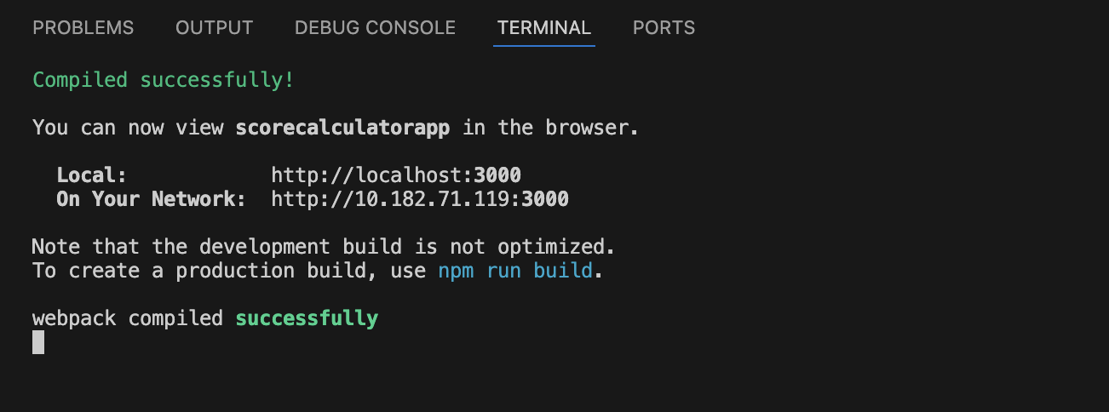
It opens the brower.
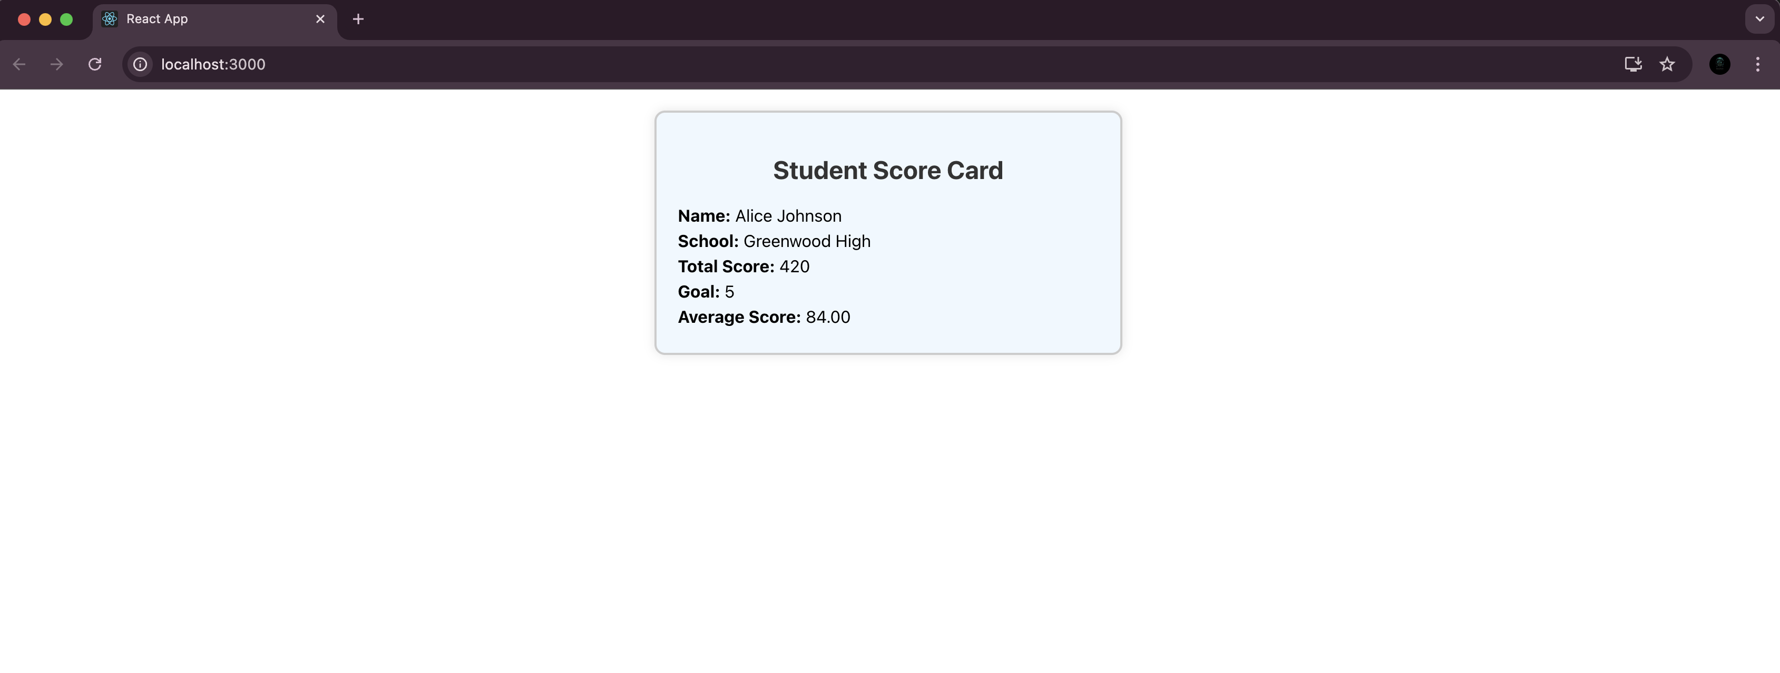

Filename : 4. ReactJS-HOL

Step 1:
Install node.js from official website and setup on the system.And Create a new folder named react4 for this project and open on vs code.

Step 2:
Run the command npx create-react-app blogapp on the vs code terminal.And redirect to the react folder named blogapp.Change the App.js code in the src/App.js directory.Create Post.js and Posts.js in the src/ directory.

Post.js:
import React from 'react';
function Post(props) {
return (
<div>
<h2>{props.title}</h2>
<p>{props.body}</p>
</div>
);
}
export default Post;

Posts.js:
import React, { Component } from 'react';
import Post from './Post';
class Posts extends Component {
constructor(props) {
super(props);
this.state = {
posts: [],
hasError: false
};
}

loadPosts() {
fetch('https://jsonplaceholder.typicode.com/posts')
.then(response => response.json())
.then(data => {
this.setState({ posts: data });
});
}

componentDidMount() {
this.loadPosts();
}

componentDidCatch(error, info) {
this.setState({ hasError: true });
alert("Something went wrong!");
}

render() {
return (
<div>
<h1>Blog Posts</h1>
{this.state.posts.map(post => (
<Post key={post.id} title={post.title} body={post.body} />
))}
</div>
);
}
}

export default Posts;

App.js:
import React from 'react';
import Posts from './Posts';
function App() {
return (
<div className="App">
<Posts />
</div>
);
}
export default App;

Step 3:
Run the command npm start on your vs code terminal.
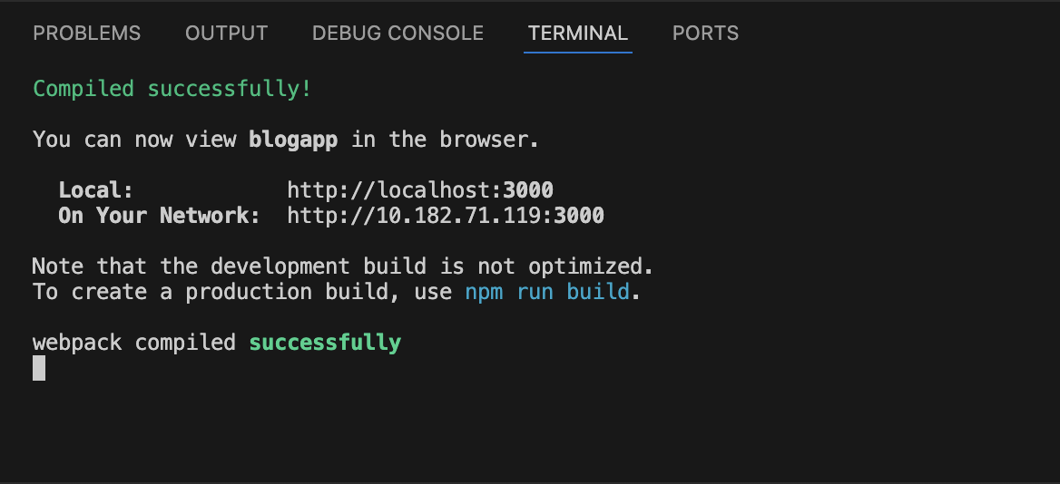
It opens the browser.
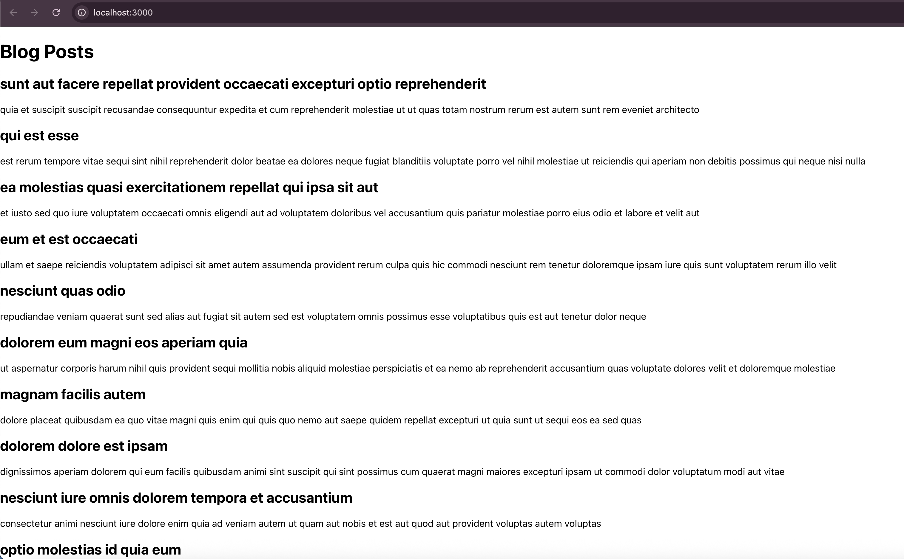
Filename : 5. ReactJS-HOL

Step 1:
They didn’t provide any zip file link on the Hands on file.So create all files for the expected output.

Step 2:
Run the command npx create-react-app cohorttracker on the vs code terminal.And redirect to the react folder named cohorttracker.Change the App.js code in the src/App.js directory.Create CohortDetails.js in the src/ directory and create CohortDetails.module.css in the src/components directory.

CohortDetails.js:
import React from "react";
import styles from "./components/CohortDetails.module.css";

const CohortDetails = ({ cohort }) => {
const headingStyle = {
color: cohort.status === "Ongoing" ? "green" : "blue",
fontWeight: "bold",
};

return (
<div className={styles.box}>
<h3 style={headingStyle}>{cohort.name}</h3>
<dl>
<dt>Started On</dt>
<dd>{cohort.startDate}</dd>
<dt>Current Status</dt>
<dd>{cohort.status}</dd>
<dt>Coach</dt>
<dd>{cohort.coach}</dd>
<dt>Trainer</dt>
<dd>{cohort.trainer}</dd>
</dl>
</div>
);
};
export default CohortDetails;

CohortDetails.module.css:
.box {
width: 300px;
display: inline-block;
margin: 10px;
padding: 10px 20px;
border: 1px solid black;
border-radius: 10px;
vertical-align: top;
}

dt {
font-weight: bold;
}

App.js:
import React from "react";
import CohortDetails from "./CohortDetails";
const cohorts = [
{
name: "INTADMDF10 -.NET FSD",
startDate: "22-Feb-2022",
status: "Scheduled",
coach: "Aathma",
trainer: "Jojo Jose",
},
{
name: "ADM21JF014 - Java FSD",
startDate: "10-Sep-2021",
status: "Ongoing",
coach: "Apoorv",
trainer: "Elisa Smith",
},
{
name: "CDBJF21025 - Java FSD",
startDate: "24-Dec-2021",
status: "Ongoing",
coach: "Aathma",
trainer: "John Doe",
},
];
function App() {
return (
<div>
<h1>Cohorts Details</h1>
{cohorts.map((cohort, index) => (
<CohortDetails key={index} cohort={cohort} />
))}
</div>
);
}
export default App;
Step 3:
Run the command npm start on your vs code terminal.
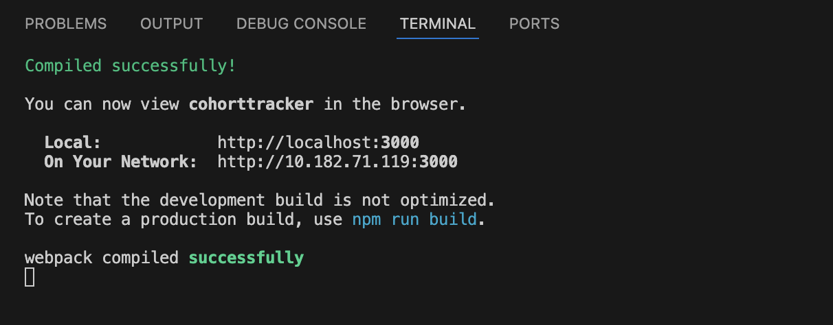
It opens the browser.
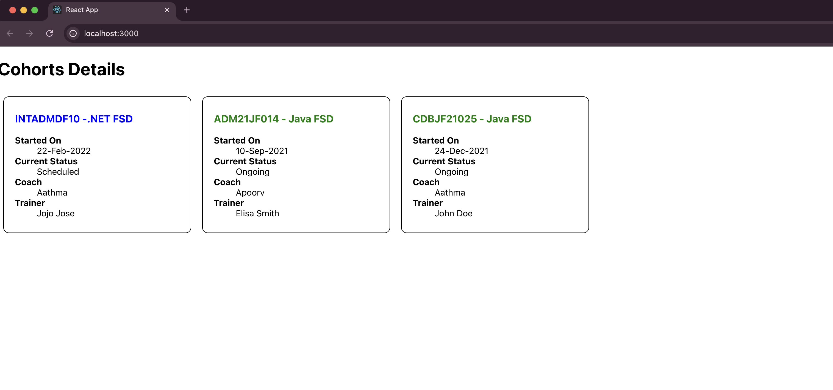
(b) Additional important hands-on
Filename : 6. ReactJS-HOL

Step 1:
Install node.js from official website and setup on the system.And Create a new folder named react6 for this project and open on vs code.

Step 2:
Run the command npx create-react-app trainersapp on the vs code terminal.And redirect to the react folder named trainersapp.Install react router through terminal through the command npm install react-router-dom.Change the App.js code in the src/App.js directory.Create trainer.js,TrainersMock.js,TrainersList.js,Home.js and TrainerDetails.js in the src/ directory.

trainer.js:
class Trainer {
constructor(trainerId, name, email, phone, technology, skills) {
this.trainerId = trainerId;
this.name = name;
this.email = email;
this.phone = phone;
this.technology = technology;
this.skills = skills;
}
}

export default Trainer;

TrainersMock.js:
const TrainersMock = [
{
trainerId: 1,
name: "John Doe",
email: "john.doe@example.com",
phone: "1234567890",
technology: "React",
skills: ["JavaScript", "React", "Redux"]
},
{
trainerId: 2,
name: "Jane Smith",
email: "jane.smith@example.com",
phone: "9876543210",
technology: "Angular",
skills: ["TypeScript", "Angular", "RxJS"]
},
{
trainerId: 3,
name: "Michael Brown",
email: "michael.brown@example.com",
phone: "5551234567",
technology: "Vue",
skills: ["JavaScript", "Vue", "Vuex"]
}
];

export default TrainersMock;

TrainersList.js:
const TrainersMock = [
{
trainerId: 1,
name: "John Doe",
email: "john.doe@example.com",
phone: "1234567890",
technology: "React",
skills: ["JavaScript", "React", "Redux"]
},
{
trainerId: 2,
name: "Jane Smith",
email: "jane.smith@example.com",
phone: "9876543210",
technology: "Angular",
skills: ["TypeScript", "Angular", "RxJS"]
},
{
trainerId: 3,
name: "Michael Brown",
email: "michael.brown@example.com",
phone: "5551234567",
technology: "Vue",
skills: ["JavaScript", "Vue", "Vuex"]
}
];

export default TrainersMock;

Home.js:
import React from "react";

const Home = () => {
return (
<div>
<h1>Welcome to TrainersApp</h1>
<p>This app maintains a list of trainers and their expertise.</p>
</div>
);
};

export default Home;

TrainerDetails.js:
import React from "react";
import { useParams } from "react-router-dom";
import TrainersMock from "./TrainersMock";

const TrainerDetail = () => {
const { id } = useParams();
const trainer = TrainersMock.find(t => t.trainerId === parseInt(id));

if (!trainer) {
return <h2>Trainer not found</h2>;
}

return (
<div>
<h2>{trainer.name}</h2>
<p><strong>Email:</strong> {trainer.email}</p>
<p><strong>Phone:</strong> {trainer.phone}</p>
<p><strong>Technology:</strong> {trainer.technology}</p>
<p><strong>Skills:</strong> {trainer.skills.join(", ")}</p>
</div>
);
};

export default TrainerDetail;

App.js :
import React from "react";
import { BrowserRouter, Routes, Route, Link } from "react-router-dom";
import Home from "./Home";
import TrainersList from "./TrainersList";
import TrainerDetail from "./TrainerDetails";
import TrainersMock from "./TrainersMock";

function App() {
return (
<BrowserRouter>
<div>
<nav>
<ul>
<li>
<Link to="/">Home</Link>
</li>
<li>
<Link to="/trainers">Trainers</Link>
</li>
</ul>
</nav>

<Routes>
<Route path="/" element={<Home />} />
<Route path="/trainers" element={<TrainersList trainers={TrainersMock} />} />
<Route path="/trainers/:id" element={<TrainerDetail />} />
</Routes>
</div>
</BrowserRouter>
);
}

export default App;

Step 3:
Run the command npm start on your vs code terminal.
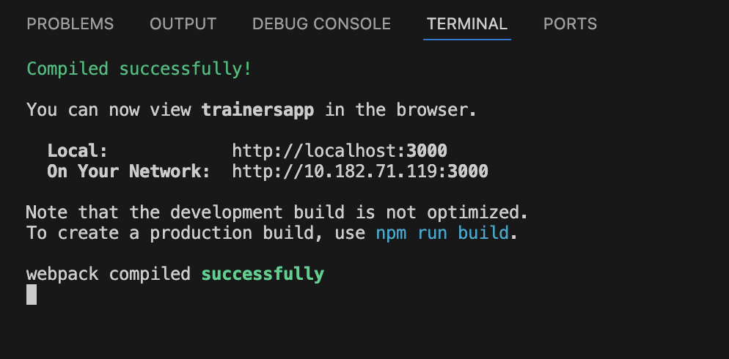

It opens the browser.
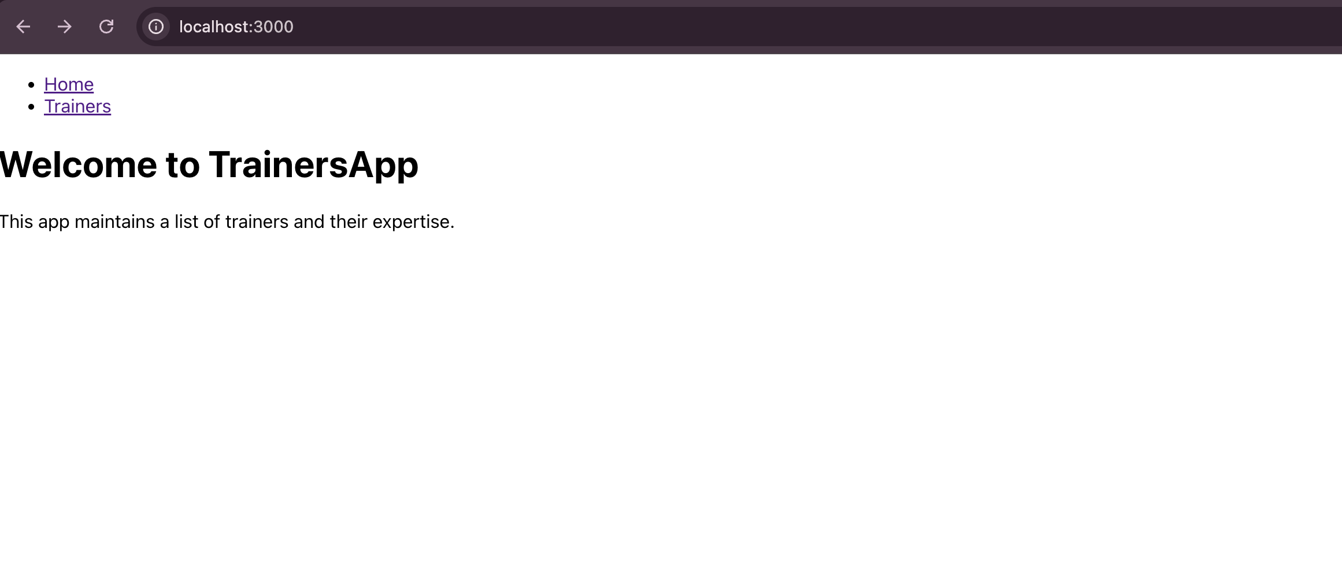

In trainers we can see the trainer names and their details.
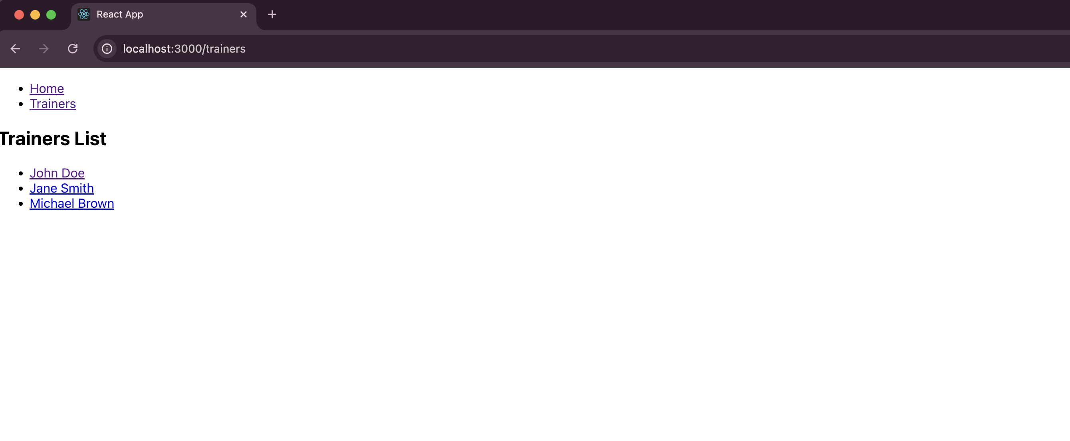
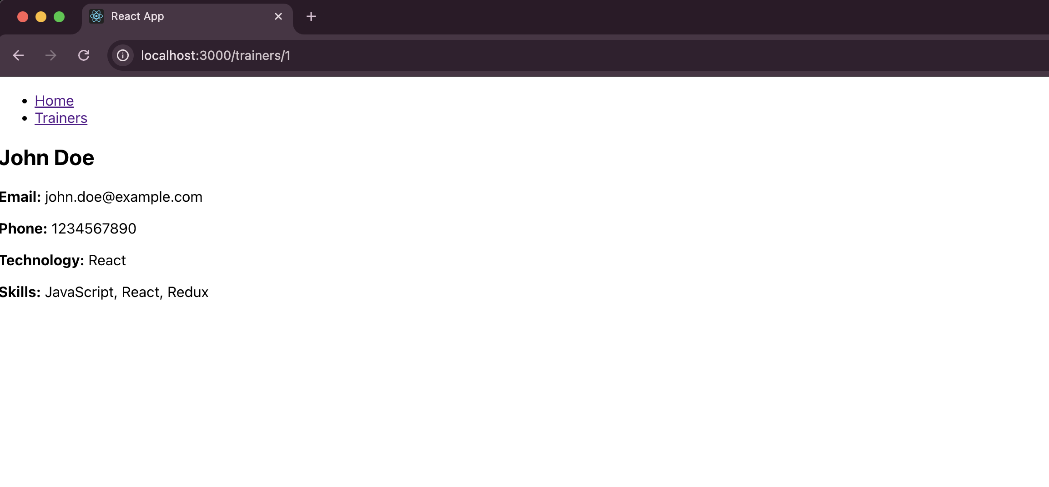
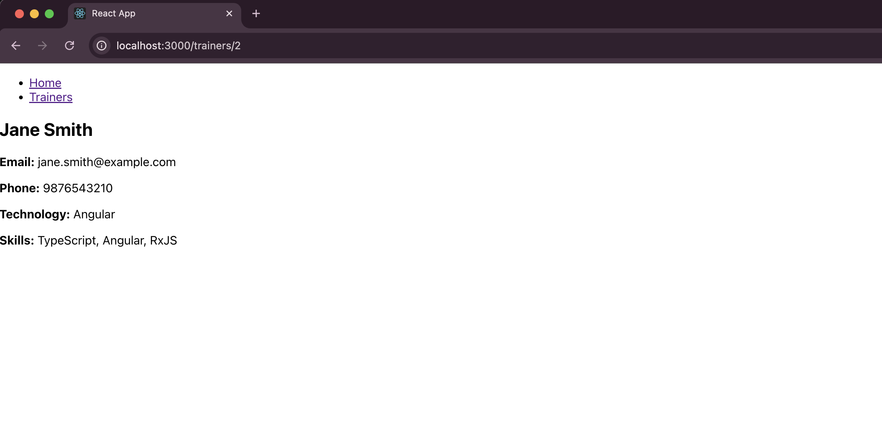

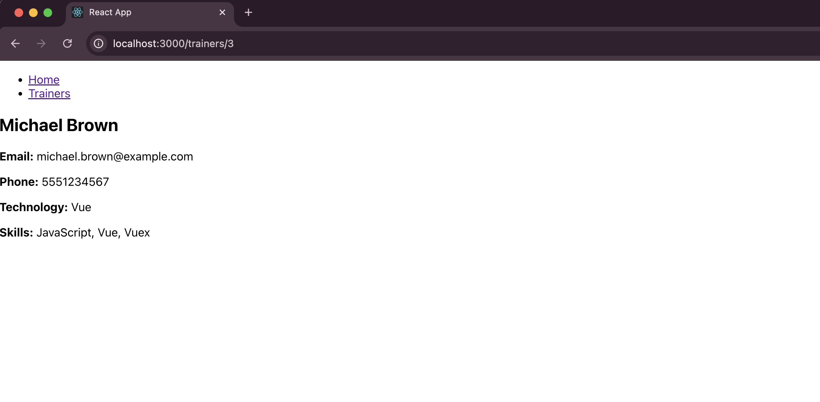

Filename : 7. ReactJS-HOL

Step 1:
Install node.js from official website and setup on the system.And Create a new folder named react7 for this project and open on vs code.

Step 2:
Run the command npx create-react-app shoppingapp on the vs code terminal.And redirect to the react folder named shoppingapp.Change the App.js and App.css code in the src/ directory.Create Cart.js,OnlineShopping.js in the src/ directory.
Cart.js:
import React from 'react';

class Cart extends React.Component {
render() {
return (
<tr>
<td>{this.props.Itemname}</td>
<td>{this.props.Price}</td>
</tr>
);
}
}
export default Cart;

OnlineShopping.js:
import React from 'react';
import Cart from './Cart';
import './App.css';

class OnlineShopping extends React.Component {
render() {
const items = [
{ Itemname: 'Laptop', Price: 80000 },
{ Itemname: 'TV', Price: 120000 },
{ Itemname: 'Washing Machine', Price: 50000 },
{ Itemname: 'Mobile', Price: 30000 },
{ Itemname: 'Fridge', Price: 70000 }
];

return (
<div>
<h1>Items Ordered :</h1>
<div className="table-container">
<table>
<thead>
<tr>
<th>Name</th>
<th>Price</th>
</tr>
</thead>
<tbody>
{items.map((item, index) => (
<Cart key={index} Itemname={item.Itemname} Price={item.Price} />
))}
</tbody>
</table>
</div>
</div>
);
}
}
export default OnlineShopping;

App.js:
import React from 'react';
import OnlineShopping from './OnlineShopping';
function App() {
return (
<div className="App">
<OnlineShopping />
</div>
);
}
export default App;

App.css:
h1 {
color: #2e7d32;
text-align: center;
margin-bottom: 20px;
font-family: 'Poppins', Arial, sans-serif;
font-size: 2em;
}

.table-container {
display: flex;
justify-content: center;
align-items: center;
border: 3px solid #999;
border-radius: 10px;
padding: 20px;
width: fit-content;
margin: 0 auto;
box-shadow: 0 0 15px rgba(0, 0, 0, 0.2);
background-color: #f9f9f9;
}

table {
border-collapse: separate;
border-spacing: 5px;
}

th, td {
border: 2px solid #666;
padding: 15px 25px;
text-align: center;
font-family: 'Poppins', Arial, sans-serif;
border-radius: 8px;
background-color: #fff;
}

th {
color: #2e7d32;
font-weight: bold;
font-size: 1.2em;
}

td {
color: #66bb6a;
font-size: 1.1em;
}

Step 3:
Run the command npm start on your vs code terminal.
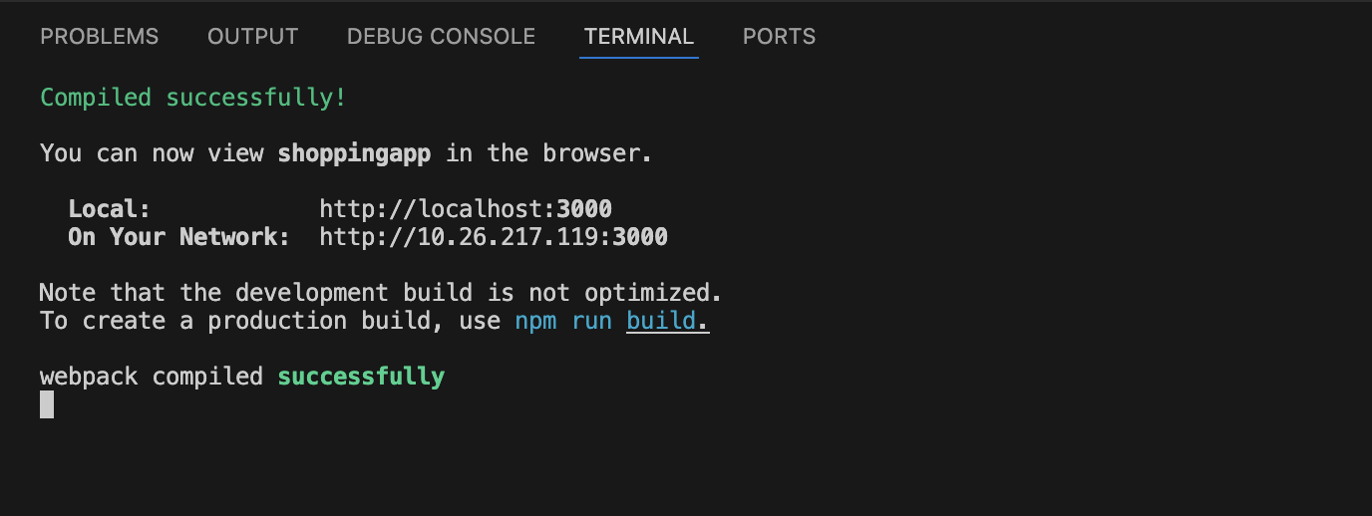

It opens the browser.

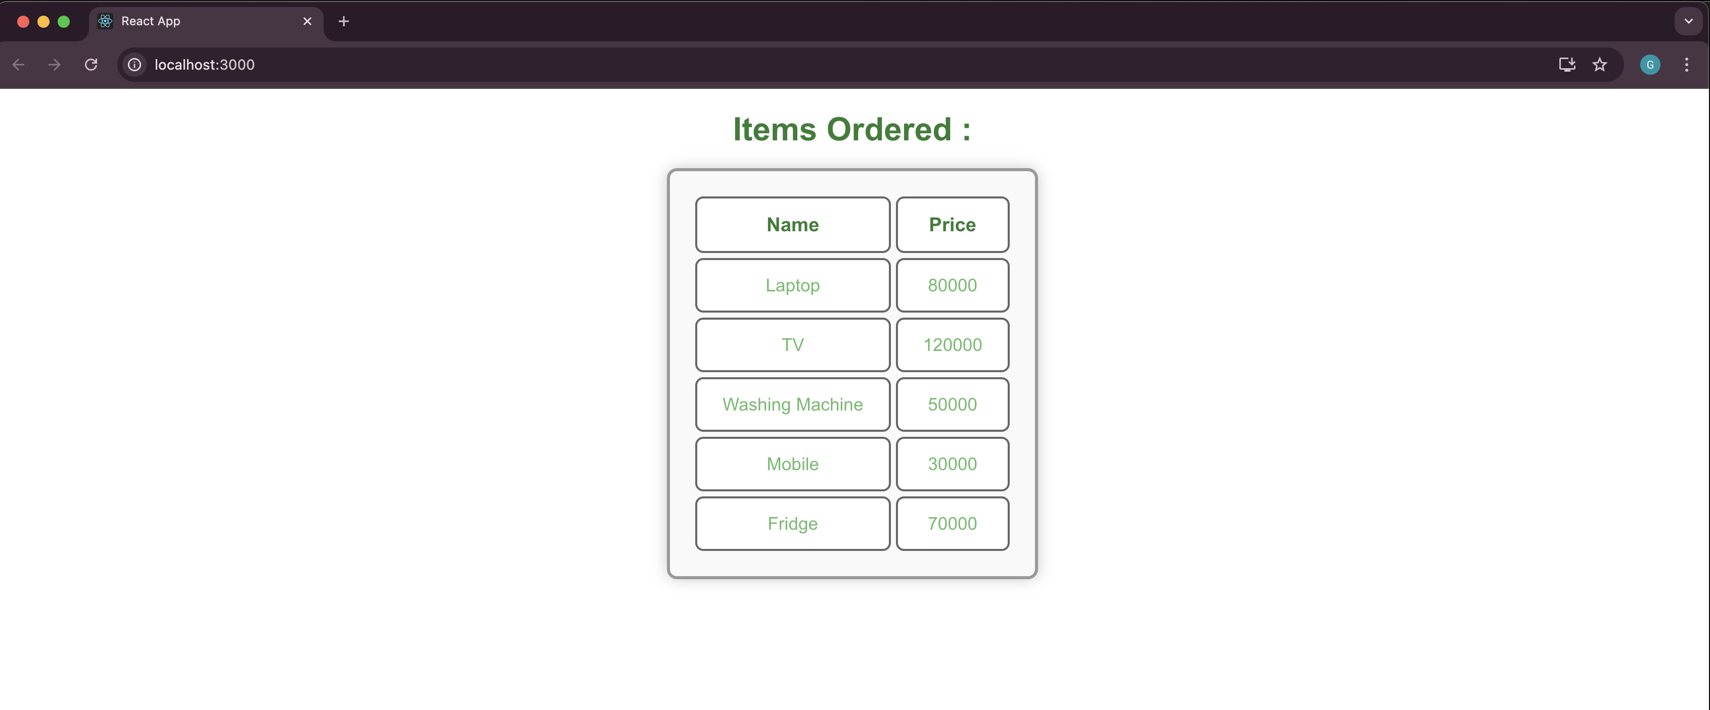

Filename : 8. ReactJS-HOL

Step 1:
Install node.js from official website and setup on the system.And Create a new folder named react8 for this project and open on vs code.

Step 2:
Run the command npx create-react-app counterapp on the vs code terminal.And redirect to the react folder named counterapp.Change the App.js and index.js code in the src/ directory.Create CountPeople.js,CountPeople.css in the src/ directory.

CountPeople.js:
import React, { Component } from 'react';
import './CountPeople.css';

class CountPeople extends Component {
constructor(props) {
super(props);
this.state = {
entrycount: 0,
exitcount: 0,
};
}

UpdateEntry = () => {
this.setState((prevState) => ({
entrycount: prevState.entrycount + 1,
}));
};

UpdateExit = () => {
this.setState((prevState) => ({
exitcount: prevState.exitcount + 1,
}));
};

render() {
return (
<div className="main-container">
<div className="entry-container">
<button className="btn" onClick={this.UpdateEntry}>Login</button>
<span>{this.state.entrycount} People Entered!!!</span>
</div>
<div className="exit-container">
<button className="btn" onClick={this.UpdateExit}>Exit</button>
<span>{this.state.exitcount} People Left!!!</span>
</div>
</div>
);
}
}
export default CountPeople;

CountPeople.css:
.main-container {
margin-top: 100px;
display: flex;
justify-content: space-around;
align-items: center;
}

.entry-container,
.exit-container {
display: flex;
align-items: center;
}

.btn {
border: 1px solid green;
background-color: lightgreen;
color: black;
padding: 5px 10px;
margin-right: 10px;
cursor: pointer;
border-radius: 3px;
}

.btn:hover {
background-color: green;
color: white;
}

span {
font-size: 18px;
font-weight: bold;
}

index.js:
import React from 'react';
import ReactDOM from 'react-dom/client';
import './index.css';
import App from './App';

const root = ReactDOM.createRoot(document.getElementById('root'));
root.render(
<React.StrictMode>
<App />
</React.StrictMode>
);

App.js:
import React from 'react';
import CountPeople from './CountPeople';

function App() {
return (
<div>
<CountPeople />
</div>
);
}
export default App;

Step 3:
Run the command npm start on your vs code terminal.
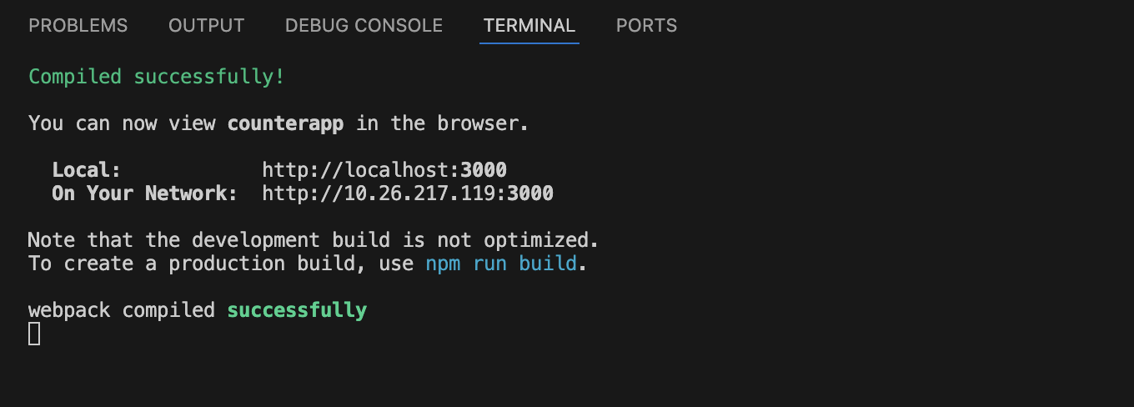

It opens the browser.if the button clicks,the count will be increase both login and exit button.
